**DIAMONDS ANALYSIS**

* **Total Data: m = 53940, n = 11**
* **Price: Target Variable[continuous variable]**
* **Carat weight : continuous variable**
* **Cut,color,clarity : Discrete variable**
* **X,Y,Z : Length in MM**
* **depth total depth percentage** = **z / mean(x, y) = 2 * z / (x + y)**
* **table%: The width of the diamond's table expressed as a percentage of its average diameter**

**'Unnamed: 0', 'carat', 'cut', 'color', 'clarity', 'depth', 'table’, ‘price', 'x','y’, 'z'**

**Removed Column**

**'carat', 'cut', 'color', 'clarity', 'depth', 'table', 'price', 'x','y', 'z'**

1. x,y, and z have a very strong relation with price but surprisingly depth (which comes from x,y, and z) doesn't has a significant relation with price.
2. Carat has a strong relation with price
3. Table doesn't have a significant relation with price or any other variable as well ( We can try dropping that when making the model)

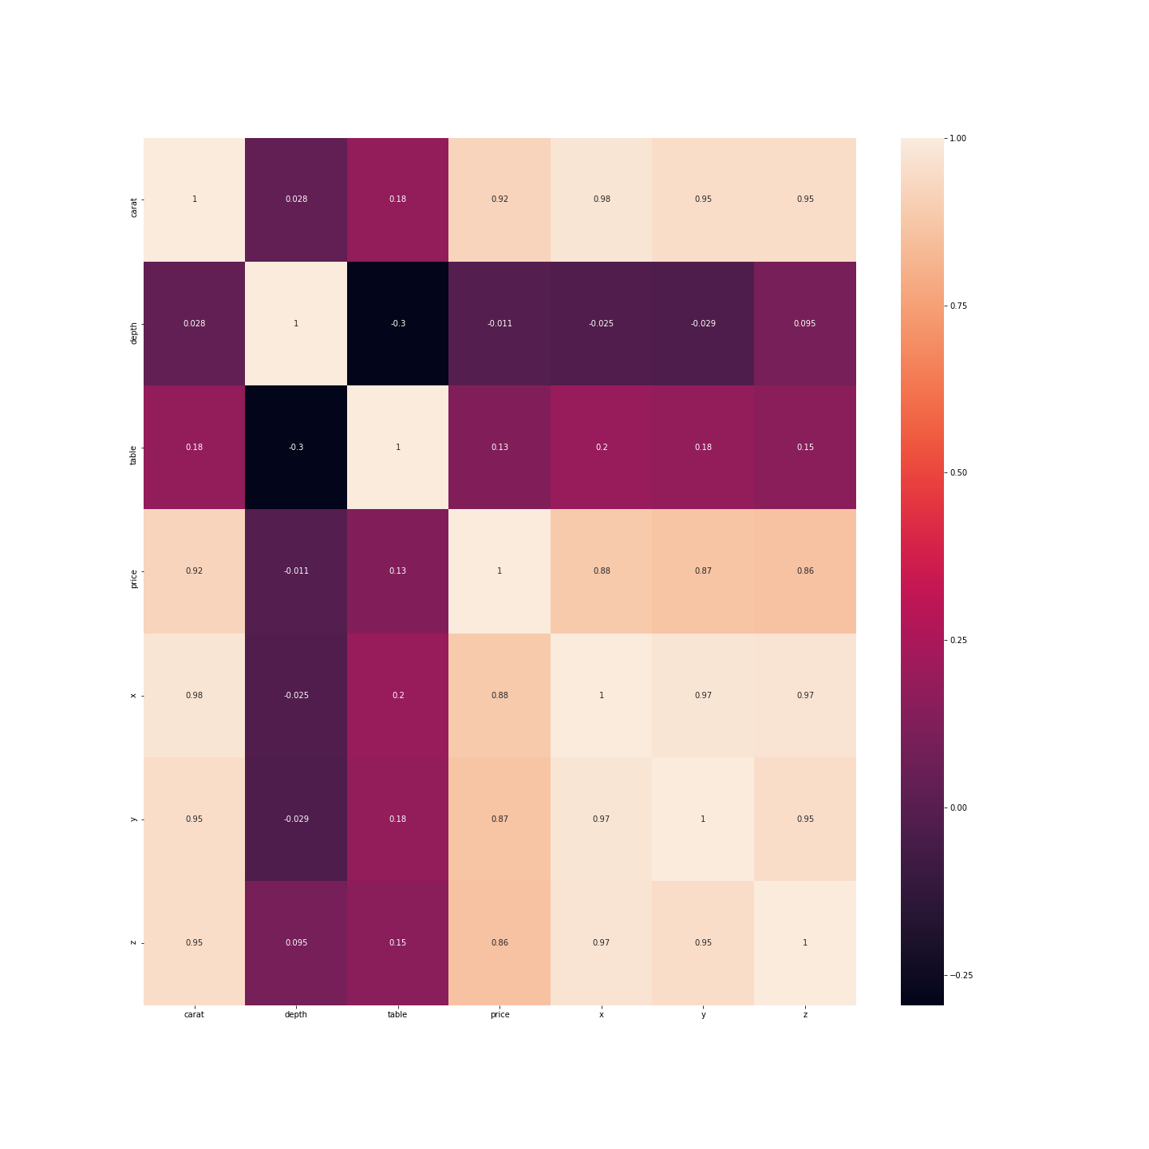

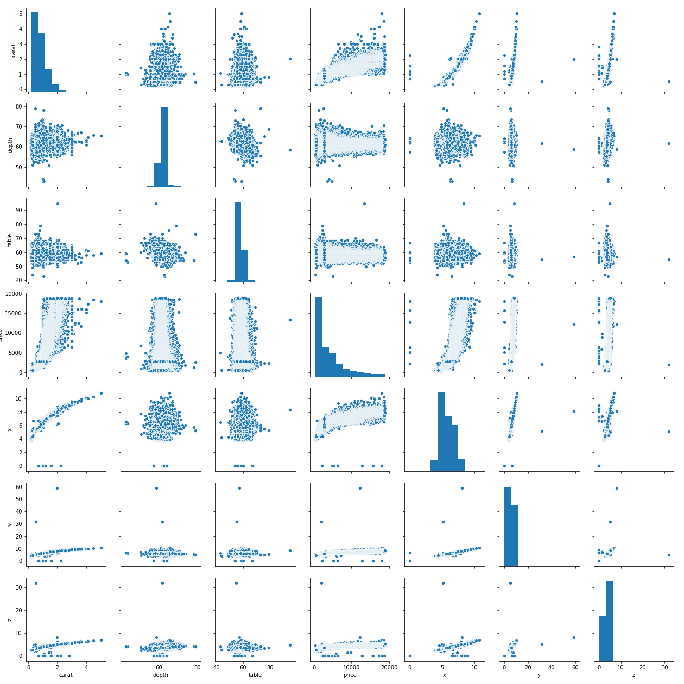

|  | **carat** | **depth** | **table** | **price** | **x** | **y** | **z** |
| --- | --- | --- | --- | --- | --- | --- | --- |
| **count** | 53940.000000 | 53940.000000 | 53940.000000 | 53940.000000 | 53940.000000 | 53940.000000 | 53940.000000 |
| **mean** | 0.797940 | 61.749405 | 57.457184 | 3932.799722 | 5.731157 | 5.734526 | 3.538734 |
| **std** | 0.474011 | 1.432621 | 2.234491 | 3989.439738 | 1.121761 | 1.142135 | 0.705699 |
| **min** | 0.200000 | 43.000000 | 43.000000 | 326.000000 | 0.000000 | 0.000000 | 0.000000 |
| **25%** | 0.400000 | 61.000000 | 56.000000 | 950.000000 | 4.710000 | 4.720000 | 2.910000 |
| **50%** | 0.700000 | 61.800000 | 57.000000 | 2401.000000 | 5.700000 | 5.710000 | 3.530000 |
| **75%** | 1.040000 | 62.500000 | 59.000000 | 5324.250000 | 6.540000 | 6.540000 | 4.040000 |
| **max** | 5.010000 | 79.000000 | 95.000000 | 18823.000000 | 10.740000 | 58.900000 | 31.800000 |

**X, Y,Z values cannot be 0[Length ,width, Height cannot be zero]**

**X – 8**

**Y- 7**

**Z – 20**

**M = 53920, N = 10**

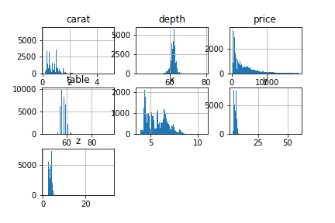

**Catogarical:**

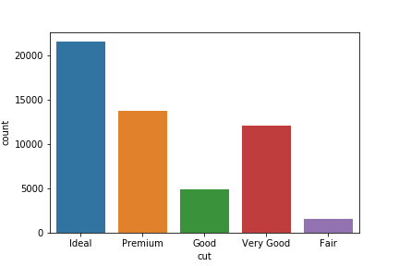

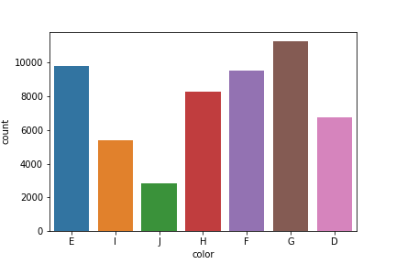

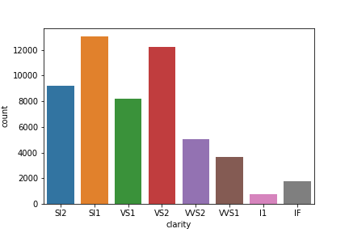

**Created dummies variable**

**Scaled continuous variable**

**Train test split.**